Smart EV Monitoring System “S.E.M.S.”

Nathan Rodriguez, Edwin Lomans, and Symone Adams

Dept. of Electrical Engineering and Computer Science, University of Central Florida, Orlando, Florida, 32816-2450

***Abstract --* The S.E.M.S. is an outdoor electric vehicle charger that is used for University of Central Florida (UCF) students and faculty. With an increase in the electric vehicle population, the need for accessible chargers have increased as well; this is why UCF has available electric chargers placed in numerous parking garages throughout the campus. These chargers perform the basic task of making sure the vehicle is efficiently charged. The S.E.M.S. charger seeks to not only perform this task but incorporate modern capabilities for students to track their power consumption and limit the use of the chargers to only UCF students/faculty using a phone application.**

***Index Terms --* Electric Vehicles, Battery Chargers, Charging Stations, Application Software, Microcontrollers, Pulse Width Modulation**

1. Introduction

The S.E.M.S. charger is designed to handle 120-volt input to charge the vehicle; this is known as level-1 charging and is the typical mode for all electric chargers. Other modes of charging include the level-2 charging which has an input voltage of 240 V and level-3 charging which uses DC voltage at a value of 480 V. Going with the level-1 charging was the best option for the S.E.M.S. charger due to accessibility; on campus, the standard output voltage is 120 V, therefore the charger can be utilized anywhere without the need to modify power outlets. The charger consists of four main parts: the power monitoring circuit, the mixed signal processor, the transceiver wireless interface, and the user interface module. Our power circuit will control the amount of current and voltage going into the vehicle and the individual MCUs used. The main microcontroller will monitor power by connecting to the electric vehicle cable. The cable used called the J1772 has two signals that communicates with the MCU directly using pulse width modulation and measures the state of charge. This information once obtained will be sent to another microcontroller that has wireless capabilities. From here, the state of charge will be sent to a smartphone application for the user to monitor their vehicle. One of the most important aspects of the S.E.M.S. charger is the limited accessibility. The charger must only be accessed by UCF students/faculty; therefore, the application will prompt the user for their UCF NID and password, turn on and off the charger, and track the power. The ability to be able to monitor power anywhere on campus is essential as well; this is why the electric charger utilizes the university Wi-Fi instead of Bluetooth which has a shorter range. All of these features represent the S.E.M.S., a smart electric vehicle charger.

1. System Overview
2. *Input Power*

Many options were available as a power source to charge an Electric Vehicle using the S.E.M.S charging station. It was determined that alternative sources, such as, solar power would require unnecessary cost to the system. The original design constraints to the project required the S.E.M.S charging station be cost conscious as well as efficient. Therefore, it was determined that pulling power from the grid would allow us to meet all sponsor requirements as well as design specifications.

The S.E.M.S charging station is rated to receive level 1 and level 2 charging based off of circuit availability. Due to the high voltage nature of charging large battery loads it was determined that the S.E.M.S circuitry would be equipped with components rated high enough to accept voltage and current levels associated with level 2 charging, however, for testing and demo purposes level 1 charging would sufficiently represent all S.E.M.S capabilities.

Level 1 charging works from a single-phase AC power outlet and is suitable for private, domestic installations and these do not need authentication and billing. The stripped-down nature of the S.E.M.S charging station requires that students and faculty may use the station without the need for billing. Therefore, the monitoring normally associated with current charging stations will only be used to monitor state of charge. Level 1 charging is the most basic form of charging currently on the market. To utilize level one charging a household outlet of a 120 voltage is need in conjunction with the on-board charging cord normally supplied with vehicle upon purchase. Level 1 refers to Single Phase Alternating current (AC) and is capable of supplying the user vehicle with around 16 Amps of current at 120 Volts which delivers about 1.9 KW of power. An Electric vehicle that is being used for short trips and that will be stationary for long periods of time at a charging station typically do not need an excess of level 1 charging.

Level 2 charging stations may use either single phase or three phase AC power from the grid. This self-contained system used for Levels 1 and 2 gives the charger the flexibility to connect to different AC charging sources. Level 2 charging is a faster more efficient form of charging that utilizes a 240-volt outlet and requires a 40 Amp circuit. Level 2 charging extracts alternating AC current from the grid at a higher rate than level 1, Then converts that AC current into usable DC current to charge the vehicle. Level 2 charging can reduce recharging a battery by up to threefold ranging from 6-9 hours depending on battery technology specific to the vehicle. Similar to level 1 charging, level 2 charging allows a user to fully charge an electric vehicle overnight, however, it is more optimal for quick charging when the user is unable to leave the vehicle stationary for longer periods of time, such as sleeping but rather fall into period conducive to activities such as shopping, work, or school.

For reference level 3 charging was considered and ultimately determined to be unsafe due to the inexperience of student design and participation, as well as the limited availability of a circuit meeting design specifications. Level 3 charging, often known as DC fast charging, is the fastest most efficient form of Electric Vehicle charging. With the use of a 480-voltage circuit DC charging directly inputs DC current into the vehicle bypassing the need to convert AC alternating current. This allow significantly greater levels of power to be absorbed by the vehicle ultimately decreasing charging times. In optimal weather conditions DC fast charging allows the user to fully charge a depleted battery in typically under an hour. While DC charging is currently the fastest way to charge an Electric vehicle, it is by far the most difficult to implement, and requires the most modifications. Due to typical student and faculty charging habits on campus, DC fast charging while the fastest is actually the most impractical and unnecessary to implement.

1. *SAE J1772*

Providing power for the electric vehicle is more than just providing the right amount of voltage; communication happens between the vehicle’s cable and the circuitry monitoring the power. The United States’ recommended type of cable is the SAE J1772 which has a five-pin configuration shown in Fig. 1. Two pins are dedicated to AC power input, for charging the vehicle only, and another pin is for ground. A pin called the pilot signal is used to check whether the vehicle is connected or not. Once the cable is attached to the vehicle, a square wave input is put through the pilot signal and its value changes according to the amount of resistance of the vehicle is supplying. The last pin is called the proximity pin and determines whether power can now be released to the vehicle. Similar to the pilot pin, it uses resistance to determine whether cable is connected and then switches an AC relay to begin the charging process. This cable was used for the S.E.M.S. due to its compatibility with 120V input and because of the higher percentage of electric vehicle owners using this type of cord as opposed to the Japanese model CHAdeMO.

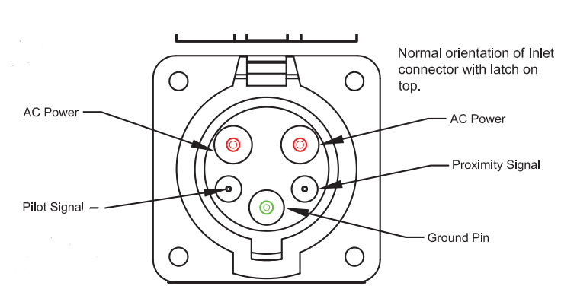

Fig. 1: SAE J1772 Pin Configuration

1. *Power Monitoring Circuit*

The J1772 Pilot is a 1khz +12V to -12V square wave, the voltage defines the state and the duty cycle defines the current available to the EV. The EVSE sets the duty cycle and the EV adds resistance from the pilot the Ground to vary the voltage. The EVSE reads the voltage and changes state accordingly; Table 1 shows a summary of these voltages and states.

|  |  |  |  |
| --- | --- | --- | --- |
| State | Pilot Voltage | Ev Resistance | Description |
| State A | 12 | N/A | Not Connected |
| State B | 9 | 2.74k | Connected |
| State C | 6 | 882 | Charging |
| State D | 3 | 246 | Ventilation Required |
| State E | 0 | N/A | No power |
| State F | -12 | N/A | EVSE Error |

Table 1: Pilot Signal voltages and state of changes.

The Pilot should have a frequency of 1kHz(1000Hz). The acceptable J-1772 tolerance is from 980-1020 Hz. Testing the frequency by attaching the EV simulator in State C or diode and 882 Ohm resistor in series is readable with a multimeter or oscilloscope from pilot to EVSE Ground.

The Pilot Duty Cycle is dependent on the Max current setting of the EVSE. We can test the duty cycle by attaching the EV simulator in State C (Charging Mode). By attaching an oscilloscope from pilot to EVSE Ground we can match the duty cycle to a rating of up to 80A. This allows us to alter the duty cycle according to required current and determine the present state of charge. In conjunction with the power distribution circuit the states are going to be monitored through analog outputs located on the power access points to ground. The states of charging are to be determined from the state of active high on the power distribution circuit.

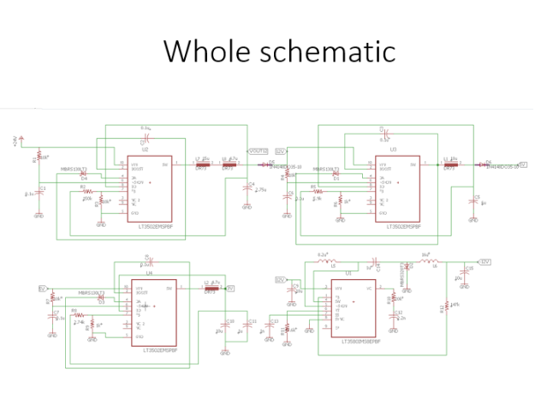

Fig. 2

1. *Wireless Communication*

One of the main goals for the S.E.M.S. was for the ability of any user to monitor the state of charge. The most common way today is through a smartphone application; this requires the charging system to have wireless capabilities. The XBEE wireless communication module was used because of its simple implementation and its compatibility with the power monitoring MCU used.

The module works in two modes: transparent and API operation. The transparent operation simply gathers data through UART from the DI pin and waits for three different scenarios. The first situation is when the amount of time that’s set by the user has expired. The second situation is when the maximum of data is stored in the packet. The third and final situation is when a command sequence is sent manually. Once either of those three situations happened, data is sent from the DO pin. API operation is similar to the Transparent with extra features including storing source addresses and setting event notifications. The module can be configured as a peer-to-peer network, meaning there is no master/slave assignment. The data flow operation from the datasheet is in Fig. 3.

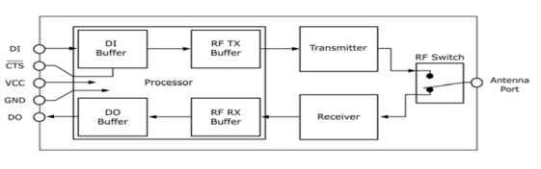

Fig. 3: Data Flow of XBEE Module

1. Hardware Design

Due to wide ranges of input voltage and current, specific design and regulated components are needed to deliver proper power within the system and subsystem respectively. To ensure product safety component configuration would be vital and necessary. To monitor signal levels accurately, specific circuitry needed to be designed and realized in a cost-effective manner. In this section, key components to the S.E.M.S charging station are justified for intended utilization.

1. *Power Supply system*

The Heavy-Duty Relay supplies 120 VAC to the main processing system. To use each component within the system it is important to configure proper operating DC voltages.

The first stage of accepting input power is maintaining safety to the system and its users. This is why a fuse protection system is enabled at the first contact point of the circuit. The main central processing unit of the S.E.M.S charging station requires roughly 18 watts of power. A circuit breaker is designed and evaluated to carry 100% of its rated current for an indefinite period of time under standard test conditions. Frequently 80% of its rated current under NEC sec. 384-16© is sufficient. This requirement determines that for our circuit breaker to operate properly within our desired specifications a .5 Amp fuse fulfills requirement. From the grid power a standard fuse holder and .5 Amp fuse are placed before any interaction with the circuit is initiated.

The next stage of the power supply system is to step the voltage down. To achieve this task, we decided to use a 120/240 volt rated transformer that outputs 24 volts when loaded. Transformers are used to increase or decrease the alternating voltages in electric power applications. The S.E.M.S charging station central processing unit does not require alternating current as a source of power so the transformers only operation is to safely step down the voltage output.

A bridge rectifier is placed at the node of output voltage from our rated transformer. This is an arrangement of four diodes in a bridge circuit configuration which provides the same output polarity for either input polarity. The bridge rectifier allows for use to take the alternating current from the grid that has been stepped down and use it as a DC signal to power our system components.

Lastly in the power supply system we needed to rectify our output to reduce ripple and ensure that the DC voltage levels are stable enough to use. Because our main processing unit is pulling power from our designed power distribution circuit, it was only necessary to deliver enough power to the distribution center. The J-1772 cord requires us to fabricate a 12-volt duty cycled square wave. This means that we are required to swing the voltage from a positive 12 volts to a negative 12 volts. This is the mechanism required to communicate with the Electric vehicle during charging protocol. This also adds instability to our system with alternating signals. The DC/DC converter that will be used to step down the DC voltage for the PWM is the LT3502A. The duty cycle for the S.E.M.S charging station requires a switching frequency relatively low. The LT3502A step down regulator switches frequencies are a rate of 2.2 MHz which will allow sufficient rising edge and falling edge modulation without losses. The input voltage ranges for 3V to 40V. The S.E.M.S application requires a 12-volt output from a 24-volt input. This is the input that begins our distribution process and has similar circuitry implemented for each stage of regulation. With regulation, we should be able to maintain a stable input for the regulator to stabilize the information signal to the Electric vehicle. This is given in Fig. 4.

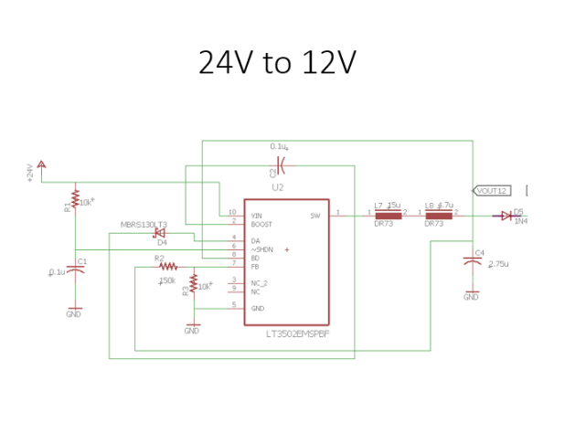

Fig. 4: Power Supply for S.E.M.S.

To ensure that at each point we do not dip below needed voltage to operate necessary components of the system, we have placed bypass capacitors in series with node outputs. A bypass capacitor is a capacitor that shorts AC signals to ground,

so, that any AC noise that may be present on a DC signal is removed, producing a much cleaner and pure DC signal. The bypass capacitors for our system need to be approximately .47 µF.

1. *Power Relay*

Electric vehicles require high voltage levels to supply enough current draw for onboard battery charging. However, cost effective methods of managing and monitoring the power do not. The central processing unit of the S.E.M.S charger is a microcontroller and requires considerably less power to operate. Due to the overwhelming difference in input power per system, it is necessary to separate said power signals to avoid damaging of the system in its entirety.

The 450 Series Heavy Duty Power Relay allowed us to redirect multiple alternating-current sources for use. Level 1 charging provides charging through a 120 volt, alternating-current plug and requires a dedicated circuit. The Electric Vehicle has onboard regulation and is feed the 120 volts directly from the power relay with no need for step down or DC conversion. However, the processing system requires the necessary circuitry to step down the voltage and utilize direct current (DC). The power relay allows us to manipulate the signal directed into the processing system without interrupting the signal into the vehicle. The 450 Series Heavy Duty Power Relay was chosen because it meets all project requirements without constraint. The max rating of 50 Amps is well within the project needs to operate the S.E.M.S charging station.

1. *Arduino Uno*

The Arduino Uno is a microcontroller board based on the ATmega328. It has 14 digital input/output pins, 6 analog inputs, a 16 MHz ceramic resonator, a USB connection, a power jack, an ICSP header, and a reset button. The S.E.M.S charging station requires constant communication from input power to the Electric Vehicle, as well as communication to the RF module to support wireless access. To operate proper charging protocols, it is essential to manipulate a Pulse Wave Modulated signal to and from the vehicle. To achieve this action, the Arduino Uno was selected because of its user-friendly capabilities.

Fabricating a switching duty cycle of positive 12 volts to negative 12 volts allows us to manage the input current into the vehicle. Through management of the duty cycle we are able to determine how much current is needed at any given moment to complete the process of charging the vehicles battery. The manipulation of the duty cycle also allows us to determine how much charge a battery is currently holding thus allowing an estimation of charge completion.

The J-1772 cord is equipped with on board regulation that allows for the car to accept an open source of current. With the use of the microcontroller we are able to accurately monitor how much of that current has been consumed by the vehicle. The Arduino Uno has Wi-Fi capabilities allowing us to relay the collected data and transfer it wirelessly where it can be interpreted.

The Uno operates at 5 volts and must be placed on the appropriate regulated node of the power supply system. With point to point access data is transferred from the analog pins of the Uno the RF controller where the data can safely be transferred to the application interface.

1. *XBEE Module Series 1*

The XBEE Module series 1 is a multipoint RF module designed to allow 2.4 GHz solutions. The S.E.M.S charging station is using the module because of its ideal applications requiring low latency and predictable communication timing. With use of the point-to-point configurations communication from the Uno to the Android phone serial port were recognizable. The XBEE module operates from 3.3 volts from regulation and is located at the final node of the power supply system.

To achieve all the data transfer needs of the S.E.M.S system required an analog input to digital output system. The XBEE Module has 6 on board 10-bit ADC inputs and 8 Digital I/O output pins which fall in the requirements needed for the S.E.M.S charging station.

With point-to-point communication, it is possible to accept the data collected from the Arduino Uno and safely transfer that data through all serial communication protocols. One constraint for S.E.M.S charging station group J is the absence of a Computer engineering or Computer Science major, this made it essential that all coding would be relatively simple and readily available. With extensive open source code, already available it would prove to be a manageable task manipulating code for S.E.M.S charging station specific use.

1. *Ground Fault*

Ground Fault Interrupt is an important part of a charging station. GFCI works by measuring the difference of current out versus current in. If there is a difference the circuit trips. Standard GFCI trips at 5mA, however EVs need a less sensitive trip point. Most commercial EVSEs use 20mA.

This Circuit work by using a Ground Fault Current Transformer (CT) from CR Magnetics (CR8420-1000-G). The CT creates a small voltage when there is a fault. The small voltage from the CT is first amplified in the first stage then compared to a reference voltage in the second. If the amplified CT voltage is higher than the reference the Op Amp goes high and causes the Arduino to register an interrupt on Arduino pin D2.

To implement the GFCI we have to solder a 8-pin socket to the proto-shield and then solder power wires to pin 4 to 5v and pin 8 to Ground. Next, we solder diodes to the Op-amp outputs at pins 3 and 5 and header pins for the CT coil where we place Zener diodes. A series of resistors with varying values allows us to manipulate the GFCI tripping point based on the requirements of the project. Register 16 needs to send a signal to the CT coil header to the Op-amp located at pin 2 and a bypass capacitor with the signal from register 17 to pin 2 and the diode located at pin 1. Setting a second output on register 15 with a 20K resistor to Ground and register 14 with a 100k resistor to a 5V input allows the Arduino to compare the signals and output a need to trip mechanism.

1. *Pilot Signal*

The J1772 Pilot requires a 1khz signal that swings from -12V to +12V. A DC/DC converter is placed within the circuit to convert 5VDC to both positive 12V and negative 12V. The converter requires a minimum draw so a 2.4k resistor and 1uf capacitor is added from each output to ground. The DC/DC converter is connected so that the 5V and GND pin lined up with the central 5V and ground rails on the board layout. The flow schematic of the power distribution is highlighted in Fig. 5.

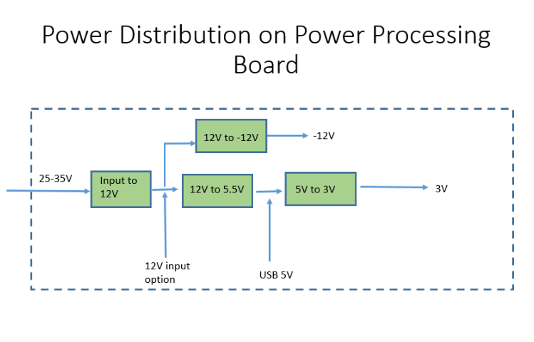

Fig. 5

The Op-amp driving the pilot signal is a LF353 which is powered by the DC/DC converter. The positive +12V output connects to pin8 and negative -12V connects to pin 4. A voltage divider with 2 100K resistors is connected to +5V Gnd and Pin 2 of the LF353. Pin 3 of the Op-amp connects to the Arduino. The output, pin 1 connects to a 1% 1k ohm resistor and then to the pilot output. A bidirectional TVS diode is also connected to the pilot output and then to ground.

To measure the pilot voltage, it is necessary to know that the charging station and the car communicate with the pilot. The Charging station must read the voltage so it can correctly respond. We solder resistors of 56k from the 5v output to Analog 1, a 100k resistor from Ground to the Arduino Analog 1, and a 200k resistor from the Pilot output to the Arduino Analog 1. This circuit work by providing a voltage divider to scale down the -12V to -12V levels. R5 provides a bias to keep the voltage positive, the Arduino does not tolerate negative voltages on the analog inputs. -12v will be 1V on A1 and +12V will be 4.5V on A1.

1. Software Design
2. *Arduino Uno*

The IDE used for the Arduino Uno is the Arduino 6.1.12 version. The programs written on this platform are called sketches; many example sketches are given with the download of this program, making the understanding of the coding easier. There is also a verify/compile feature that involves debugging any code written. When starting a sketch, once the port number has been identified, any data can be sent to the device by typing it into the serial monitor. The serial monitor will also display data that comes from the Arduino.

For the S.E.M.S., the Arduino will receive an analog input and convert it to a digital input. The Arduino has 6 channels for the 10-bit ADC; the input voltages will be between 0 and 5 volts. The program begins by first setting the analog pin that will read the voltage and then by setting the baud rate. In this case a baud rate of 9600 is chosen; the most common among many devices usually used as a default. Next, a simple loop is set up where the analog input is read and printed on the serial monitor. The program constantly loops to compensate for the changing of power in the electric vehicle.

The next step is to take this input and send it to the wireless module. For prototyping with the Arduino, the 3.3-volt pin of the Arduino should be connected to pin 1 of the XBEE module, the ground pin is connected to pin 10 of the module, both the TX pins for the Arduino and module are connected to each other, and both the RX pins are connected as well. The TX pin on the module is for data output and the RX pin is for data input. The next section discusses how to send that data from the XBEE module to the smartphone application.

1. *XCTU*

The platform used for the XBEE module is called XCTU and is used to configure the module to any mode available. In this case, the module will be set in AT mode by choosing the AT parameter, setting a run time, setting a baud rate, and choosing active scan. Active scan is reserved for Wi-Fi modules that want to connect to a certain Wi-Fi hotspot. A list of Wi-Fi connections is shown and the user simply chooses which one. Another wireless transceiver that was considered was the CC3200 from Texas Instruments. However, because of the simplicity of the XBEE module and the temperamental nature of the CC3200, the XBEE was the best choice.

The XBEE module can also be easily mounted on an MCU to provide wireless connectivity to the S.E.M.S. For this project, the Arduino Uno was used for power monitoring purposes. This is easily implemented by setting the destination address on the wireless module equal to the Arduino. Once data is collected from the Arduino, the XBEE module will broadcast this data using Wi-Fi to the Android application. The next section below details the software involving that application.

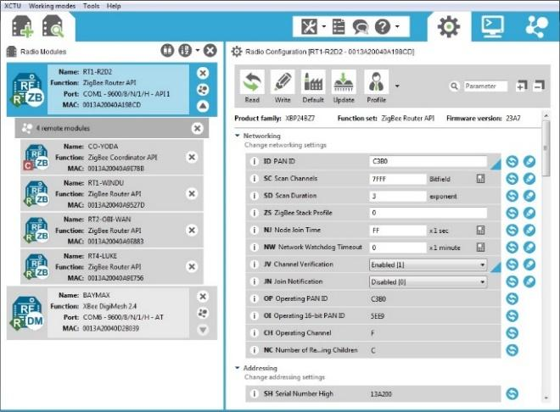

Fig. 6: Example of XCTU software

1. *Android Studio*

An Android application was designed using Android Studio. Android studio is a popular Integrated Development Environment (IDE) with a smartphone emulator and USB connection for prototyping purposes; the phone used for testing this project was the Nexus 4 Android device. The application has two xml files, files written in Markup Language, where the design and format of each display is written. The first xml file shows the Sign in Page which satisfies the security goals of the S.E.M.S. Only a UCF student/faculty can access the application by typing in their NID and Password. Both of these constraints are confirmed using a database. For the purposes of this project, a database was coded using an API called SQLite Database, a feature of Android Studio. From there, generic NID’s and passwords were entered into the database for testing. Once NID and password is confirmed, the application flips to the next xml file; another display that will show the state of charge.

Android Studio uses Java computer language to perform the tasks created by the xml files. The Main Activity Java file is where the NID and password elements are compared to the database. The Display Java file is where the connection between the application and the Wireless Transceiver happen. Upon pressing the connect button, the code will implement the Wi-Fi peer-to-peer network, another feature that is available in Android Studio; similar to the XBEE module, there is no need for a master/slave configuration. The application will receive the state of charge from the wireless module.

1. Conclusion

Technology today requires that every electronic device have some smart capabilities. It is rare to find any system that doesn’t have a monitoring system and smartphone application. The S.E.M.S. gives UCF the opportunity to bring this technology to electric vehicle owners and compete with other smart EV chargers. Compared to other similar chargers, the S.E.M.S. has a lower price requiring only a simple power circuit, a microcontroller serving as the main MCU, and a wireless module. The phone application will greatly improve the electric vehicle owner’s experience by allowing them to check their vehicle’s progress. Finally, one of the most important goals of this project, was adding security measures. With the application, only UCF student/faculty can use the S.E.M.S. properly.

AUTHORS

**Nathan Rodriguez**, is graduating electrical engineering student at the University of Central Florida and is currently interning at Lockheed Martin in the Analog Electronics group. His interests include circuit modeling/simulation and RF component design. After graduation, he will work at Lockheed Martin as an electrical engineer.

Power management

**Edwin Lomans** will graduate with a bachelor’s degree in Electrical Engineering from the University of Central Florida. Upon graduation, he hopes to enter the workforce teaching applied physics and mathematics to children while continuing his own educational goals.

**Symone Adams** is an Electrical Engineering student attending the University of Central Florida. After school, she will pursue a profession in the electronics. Main interests include semiconductor devices and the fabrication process.

ACKNOWLEDGEMENTS

We’d like to thank Dr. Richie and Professor Lei Wei for guiding us throughout the two semesters of Senior Design and Don Harper from the Texas Instruments lab in the Engineering program for always helping out when we needed it. Finally, we’d like to thank Richard Raustad from the Florida Solar Energy Center, our sponsor.

REFERENCES

[1] XBEE RF Module datasheet Digi International Inc. <http://www.digi.com>

[2] Modular EV Power LLC <http://modularevpower.com/Images/avc1/AVC2%20instructions%201_2.pdf>

[3] Digi XCTU software Digi international Inc. <https://www.digi.com/products/xbee-rf-solutions/xctu-software/xctu>